Better Immunization Data (BID) Initiative Country Consultation Meeting Summary Report

Nairobi, Kenya |23-24 October 2013

“With this initiative, we want you to lead. Better immunization data can drive improvements and we can reinvigorate the data culture in a way to position routine immunization as a backbone of health services. This is dependent on all of you and your colleagues in the field. This is a partnership with you in the lead.” – Dr. Orin Levine, Bill & Melinda Gates Foundation.

Executive Summary
Over the past several months, the Better Immunization Data (BID) Initiative has conducted outreach to ministries of health in Africa to convene Expanded Program on Immunization (EPI) and eHealth decision-makers in order to discuss challenges and opportunities for improving data quality and use around immunization coverage. On the 23rd and 24th of October, 2013, the Bill & Melinda Gates Foundation hosted a country consultation meeting in Nairobi, Kenya, bringing together over 20 country delegates and members from supporting organizations, such as UNICEF, World Health Organization (WHO) headquarters (HQ), and WHO’s African Regional Office (AFRO). Sessions were organized to gather important input for the BID Initiative and were structured around the following key objectives:
- Discuss with national-level leaders, UNICEF, WHO–HQ and WHO–AFRO, the information system tools, data collection tools, and standards being formed or implemented across Africa.
- Articulate which current information system products and which data quality and use policies and practices are working well today (to link with and incorporate immunization data), and where existing challenges remain. This will include identifying which existing efforts and information systems have been prioritized by the participating governments for scale. This will be critical moving forward, as any immunization solution will also need to extend to other health areas.
- Learn about the proposed Bill & Melinda Gates Foundation concept, what is innovative about it, and provide feedback on which aspects are appealing, which aspects complement other work, and which aspects have been tried previously, and discuss the opportunities and challenges in implementing a program of this nature. This session will also include a discussion of different projects and member country experiences with implementing data quality and use and information communications technology (ICT) programs at scale.
- Learn about the proposed peer-to-peer immunization data learning and support network and discuss how this overlaps or complements existing networks. Review case studies from countries with strong immunization data systems, including what programming areas and best practices they use, and which experiences from other geographic regions (e.g., other countries in Africa, Latin America, Southeast Asia) offer alternative perspectives that would be interesting for participants.

Active participation from country delegates during the sessions provided valuable insights that will help shape and guide the next steps of the BID Initiative. Key takeaways include:
- Systems and processes need to find the balance that meets the needs of health care providers, are simple enough to integrate into day-to-day workflows, and also contain relevant indicators to improve data quality and use.
- Challenges exist due to a lack of integration with disparate technology systems and processes—these need greater synchronicity and harmonization.
- Empowering EPI managers at the national, sub-national, facility, and community levels to make evidence based decisions will facilitate improvements in data quality; this, in turn, is a feedback loop that nurtures a culture of data use for decision-making.
- Technology systems require training, capacity building, and maintenance at all levels—local and national—to facilitate improvements in data quality and use and to foster sustainability; finding key points of interoperability among current systems will help streamline this process.
- EPI and eHealth workers require a common language to help better understand how to bring together expertise and share accountability in improving immunization data quality and use for better decision-making; creating a joint learning network or group where information can be shared among peers is valuable.

Country Delegates:

Sanou Moussa, Burkina Faso  Sylvestre Tiendrebeogo, Burkina Faso  Soualihou Noufe, Cote, D’Ivoire  Adama Sanogo Pongathie, Cote d’Ivoire  Dominic Kwabena Atweam, Ghana  George Bonsu, Ghana  Collins Wabomba Tabu, Kenya  Chea Sanford Wesseh, Liberia  Cidalia Dorete Baloi, Mozambique  Basilia Daniel Vaz, Mozambique  Charles Mamman, Nigeria | Mustafa Zubairu Mahmud, Nigeria  Richard Gakuba, Rwanda  Ousseynou Badiane, Senegal  Martial Coly Bop, Senegal  Dorothy Nteo, South Africa  Johann van den Heever, South Africa  Dafrossa Cyrily Lyimo, Tanzania  Walter Ndesanjo, Tanzania  Calvin Kalombo, Zambia  Josephine Simwinga, Zambia

Organizers and attendees from affiliated institutions:

Skye Gilbert, Bill & Melinda Gates Foundation,  United States  Orin Levine, Bill & Melinda Gates Foundation,  United States  Greg Widmyer, Bill & Melinda Gates Foundation, United States  Tim Wood, Bill & Melinda Gates Foundation,  United States  Anne LaFond, JSI, United States  Lora Shimp, JSI, United States  Henry Mwanyika, PATH, Tanzania  Jessica Mooney, PATH, United States | Liz Peloso, PATH, Canada  Brian Taliesin, PATH, United States  Jason Walton, PATH, United States  Laurie Werner, PATH, United States  Katherine Wilson, PATH, United States  Meredith Kimball, Results for Development,  United States  David Brown, UNICEF, United States  Dmitri Davydov, UNICEF, United States  Richard Mihigo, WHO–AFRO, Republic of Congo  Jan Grevendonk, WHO–HQ, Switzerland

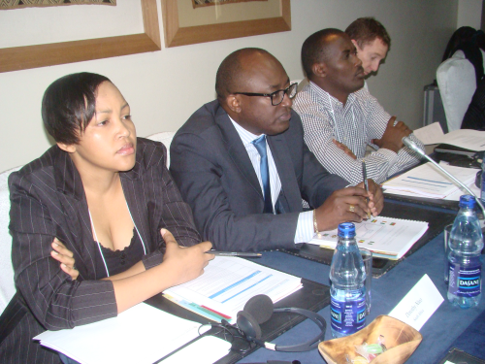
Session Highlights

Welcome to the Group

Dr. Orin Levine, Bill & Melinda Gates Foundation
- You are not alone in undertaking this effort—challenges such as stock-outs and access to timely and accurate data are familiar to everyone.
- We want and need you to speak openly and honestly on what you want to get from this initiative, how can it be structured and organized.

Mr. Collins Wabomba Tabu, Ministry of Health, Kenya
- Kenya is privilege to host this meeting here, which is the first of its kind, and we hope to have many more in the future.
- This is a dynamic field and we need to keep up with the trends.
- We have had many data quality challenges as countries and want to work to improve this, to make decisions on better data; to have the best data so we can achieve our objectives.

Data Quality and Use in Practice: Experience and best practices on improving data quality in EPI

Mr. Johann van den Heever (South Africa) and Dr. Dafrossa Lyimo (Tanzania); Moderator: Mr. Greg Widmyer (Bill & Melinda Gates Foundation)

Key Takeaways
- In South Africa, there were surprising and important findings around data collection, utility, and quality: the general lack of knowledge and skills of important staff; low data quality; no ownership of data; data sent to the next level without validation.
- Barriers to getting information: heavy tally sheet burden that doesn’t collect all of the indicators needed; complexities; no logistics component; un-linked systems and not web-based; stock balances at lower levels than reality.
- In Tanzania, the health management information system (HMIS) for the Ministry of Health and Social Welfare—working to improve and use the District Health Information System (DHIS) to strengthen their system; District Vaccine Data Management Tool (DVDMT) used to collect immunization data, and there is an eHealth strategy. Performance monitoring chart now used at the facility level as well as the district level to help understand if they are performing well or not. With DVDMT, this can all be calculated automatically on a monthly basis to better understand trends, dropout rates, coverage, and can see which are the poor performing regions, and also gives context to help understand why some districts are poor performers.
- Tanzania lessons learned from harmonizing records: use the system to analyze data at district level; store data electronically, which requires computer literacy to use DVDMT better; need to reduce work load at national level; minimize errors, increase timeliness and completeness; provide wide range of indicators.
- Way forward: tracking cold chain; transportation system; need to integrate systems (eLMIS is helping); sustainability.

Systems planning, eHealth architecture and technology infrastructure: How to avoid building an immunization “silo”

Mr. Dominic Atweam (Ghana) and Dr. Richard Gakuba (Rwanda); Moderator: Mr. Tim Wood, Bill & Melinda Gates Foundation

Key Takeaways
  - Effective use of data can be a long road, and both Ghana and Rwanda began their eHealth efforts a decade ago.
  - Duplication of data sets can lead to a large burden on health workers. Individuals in Ghana were spending five to seven days each month filling out forms. They were able to eliminate some forms that were used as reports.
  - Duplication can cause confusion with the indicators when staff try to determine which of the similarly named values were included in the calculation. They convened stakeholders to determine the common definition of data. They continue to monitor that the data that is collected is being used.
  - Provide alternate options to collect and enter data where there is no connectivity.
  - Made sure capacity was built within the country to maintain and support the different components of a system.
  - Built demand for data from the system by requiring that reports reflect the information from the system, have a simple dashboard as the first thing a user sees, and have decentralized planning whereby they are making use of their own data from the system.
  - Individual records are better than the aggregate, as aggregates can hide information that may be important for operations (e.g., cholera outbreak along the border).
  - Success of the system is measured by its use and that the data goes somewhere and is acted upon.

WHO tools and best practices: Discussion of what efforts are underway at HQ and the AFRO region

Dr. Richard Mihigo (WHO–AFRO) and Mr. Jan Grevendonk (WHO–HQ); Moderator: Dr. Orin Levine, Bill & Melinda Gates Foundation

Key Takeaways
- Current efforts: strengthening partnerships; immunizations and vaccines development (IVD) integrated info system (work in progress to take advantage of the promise that technology can provide to improve the way we work); integrated data management training modules (work in progress to support gathering data in the field).
- Challenges: weak health systems; denominator issues and some on numerator as well; confidence in data breaks down at lower levels of health system; limited use of data at different levels, especially at the lower levels; limited (or no) internet connectivity; human resource capacity at all levels; lack of availability of tools; more and more is demanded from EPI.
- New technologies that can make a difference: The Optimize project, barcodes, temperature monitoring; ecosystem of current solutions being developed.
- BID Initiative can really help to see what else we can do for health workers to make their jobs easier and more effective, and can help develop/inform: guidance, standards, and systems and tools that can be used for countries.
- Role of WHO: set standards for health and health systems; provide guidance to member states; provide tools and implementation support where member states request it; look at scalability and sustainability of work; not either/or with partners, but also there to help advise and support member states through the process.
- Process within WHO to acknowledge that health workers fill out many forms—how to minimize this?
- WHO–AFRO tools in development/use: Routine Immunization Module (RIM)—used at national level; some countries using sub-national (e.g., DRC); DVDMT—to help district level analysis, including pictorial (however, culture of data needs to be nurtured—once data are entered in systems, the data are pushed up but not sent back to the lower levels); African National Health Observatory – in creation by WHO to provide a “real-time” system.
- IVD integrated info system (work in progress)—Quarterly data meetings (Inter-country Support Team [IST]), Immunization Data Quality Self-assessment (DQS)/Data Quality Audit (DQA), feedback process; WHO–AFRO is developing integrated data management system for use in countries.

Overview of the BID Initiative

Ms. Liz Peloso (PATH)

Key Takeaways
The BID Initiative’s strategy is based on the premise that better data, plus better decisions, equals better health outcomes. It is designed to shine a light on the challenges surrounding data collection, quality, and use, and will identify practical, country-owned, country-led solutions in immunization that could spread to other health interventions. There have been lots of attempts to fix these issues in the past, and we want to build upon and tie together those interventions, tools and strategies that are already working well. BID is not another project—it is an initiative that we are inviting you today to join that should last long beyond any funding to us. Countries have many technologies already in them—what they don’t always have is a way to tie them all together. We seek to partner with countries to design the components that will tie these things together. The basic principles guiding the BID Initiative include:
- Utilize a coordinated approach. Coordinate with other key initiatives and organizations to collaborate on and/or share experiences to strengthen national immunization systems and integrated delivery of care.
- Country ownership and capacity development. Focus on countries’ primary ownership and responsibility for establishing good governance and for providing effective, high-quality immunization services for all, as well as identifying and addressing capacity-building needs.
- Interoperability. Where possible, any system modules developed will be closely coordinated with existing information system dependencies.
- Innovation. Leverage the latest learning and technology to ensure the design of an innovative solution.
- Sustainability. Consider the solution’s need for long-term sustainability throughout its development process and the work with demonstration countries.
- Openness. Remain committed to openness and include pro motion and use of open architecture, industry-based standards, and transparent, shared processes and methodologies, and openly share requirements and other technology knowledge components.
- Strategic reuse. Organize to extract reusable components from appropriate projects and build new, shared components and platforms as required.
- Research, monitoring and evaluation. Contribute to the body of knowledge that informs future investment through utilization-focused research.

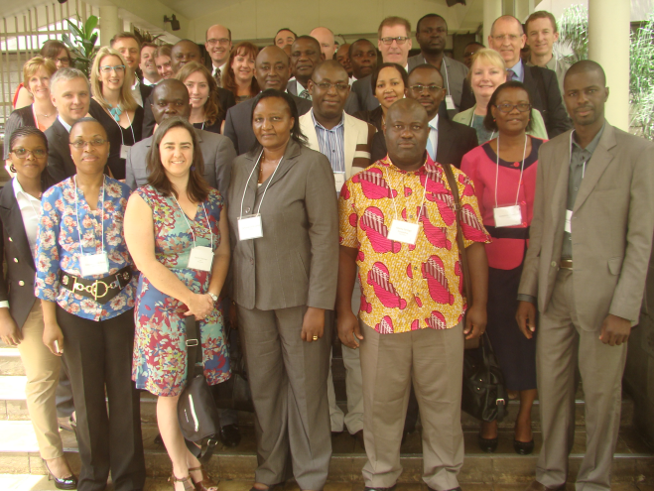
It is important before you know what information systems to buy or design, to know WHAT problems you are trying to solve first. “Enterprise Architecture”—a concept similar to designing plots for a garden—helps all stakeholders in a country think about how systems and products work together across an organization or ministry of health. This includes addressing critical issues of what policies govern information flows and producing a list of key requirements.

What’s in it for you? We will look at one country to fund at national scale implementation, then two others to do at sub-national scale. The BID Initiative will fund the packaging and identify new financial streams; then countries will work with many other partners to fully implement.

Better Immunization Data (BID) Initiative Concept Breakout Session Summaries

Products
Sustainability is very important—how do we maintain the processes? Data security and ownership to allow everyone to have access, and regular maintenance of systems are all very important. How do we ensure this?
Even though the current focus is EPI, we should look beyond just immunization toward a holistic way to improve the full health system. Connectivity is a challenge, so we must address how to have an offline mode as well as online, in case data needs to be uploaded later. Data flow and feedback are important so that those who enter data can be given feedback on their performance and what action they need to take to improve the work. Half of the group was from eHealth and half was from EPI, but it was clear that everyone was able to participate in the activities. This speaks to the challenges we will have to integrate groups in the future and the importance of developing a common lexicon.

Practices
Simplification and harmonization of tools is needed at all levels, as well as accountability, so follow-up on activities identified on action plans is important, as well as ongoing, regular supervision and data quality audits.
Training is needed for guidance on how to use tools and reporting forms and the data generated. In addition, instant data visualization to improve the strategic use of data would motivate health workers to take ownership of their services. Also, an assessment on the effectiveness of performance-based financing is important.

Joint Action for Improved Immunization Data (JAIID)
The BID Initiative put forth the hypothesis that a peer learning network that could deepen connections within the immunization and eHealth communities to share best practices, collectively address challenges and acquire practical knowledge through practitioner led learning could augment existing immunization forums (e.g., Technet, EPI manager meetings). During discussions on Day 1, participants had the opportunity to reflect on this hypothesis, discuss whether the BID Initiative should develop a peer learning network, and consider the types of activities the network could support. Participants expressed resounding agreement that there would be value in launching the network, offering them the chance to learn from the experience of peers in other countries, build new linkages with colleagues from their own countries from other disciplines (e.g., eHealth) who they don’t see frequently enough. A number of topics were already identified as good opportunities for learning and exchange. For instance, how can we get a more reliable denominator number without a national identifier? How does Nigeria manage its community health information system? How is Zambia using incentives to encourage timely reporting at the district level?
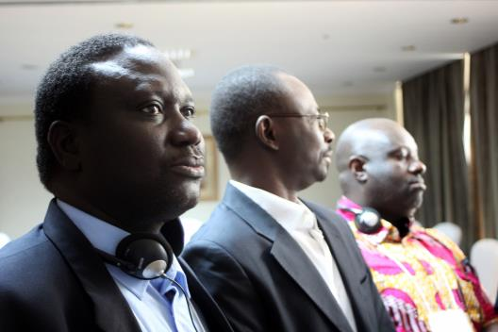
Individuals also raised questions about what activities would be included in the network, when the network would launch, what the structure would look like, and who should be involved. Thankfully, almost every individual expressed interest in designing the network, so we will be seeking your feedback on each of these components soon. Specifically, we will begin conducting phone interviews with participants in the countries in November and December to gather your opinions on the network structure and the ideal timing for the next gathering. Whatever the ultimate design is, the BID Initiative, WHO, and UNICEF are all committed to supporting complementary activities that can advance progress across the region.

Defining national priorities in immunization information systems: an introduction to the collaborative requirements development methodology (CRDM)

Ms. Kate Wilson (PATH)

Key Takeaways
Overview: CRDM is a methodology to build shared architecture and country specific solutions in order to find common elements in EPI. CRDM leverages resources, as the work goes more quickly as common pieces have already been mapped out. The BID Initiative will try to support the common elements that will make it easier for a country to adapt to inform country specific architecture.

Steps of CRDM:
- Domain
- Process framework
- Business framework
- Activity/task model: What is the common task flow? How do you do your work and what is common across the work flow?
- Requirements: What the system must or should do; should be easy to understand and say what you’d like the system to do.

Participants were then asked to review the CRDM framework and provide substantive feedback.

Reaching our goal: Drivers of information system strengthening

Ms. Anne LaFond (JSI)

Key Takeaways
- We know where we would like to go with this work and want your input on how to get there.
- Hypothesis: the lack of quality data or strategic use of data impedes the performance of the immunization system; we must adapt and tailor approaches in each country; no one single strategy will be the answer for any country.
- Madagascar example: Data-based strategy for data quality improvement, guidelines, improved performance by using the data better; not just one strategy but multiple interventions to help the system improve.
- How can we improve data quality, and strategic use? Look at the health worker in the context of a wider system, connected to national health information system within the health system, and larger global immunization goals and obligations.
- What drives the performance of an information system? Post- Licensure Rapid Immunization Safety Monitoring (PRISM ) framework—quality and strategic use are technical, organizational and behavioral determinants that help a system work effectively:
- Technical—data generation architecture, how we design a system, data points.
- Organizational—exist within an organization, information culture, structure of health system, autonomy, context and how it is used to encourage and motivate staff.
- Behavioral—people, efficacy, autonomy and motivation.
- What are the key drivers of performance? Africa Routine Immunization System Essentials (ARISE) found that when performance improved they had a regular review process, including peer review, supervision to promote good practices; camaraderie, competition, and follow up on the data they are producing helped to motivate; looked at success rather than only at the gaps.

PRISM Breakout Session
Overall the country teams raised many of the issues that were discussed during the Day 1 breakout session on Practices. They primarily focused on the barriers to data quality, rather than discussing strategies to address data quality or either the barriers or strategies for the strategic use of data. The main issues discussed were:
- Timely and accurate data
- The limited resources at the facility-level (single staff with competing priorities that deter time allocated to reporting)
- Denominator issues

Stakeholder Mapping Exercise
Participants were grouped together by country and asked to identify three levels of key stakeholders they would engage:
- Priority people to consult (could not participate without their buy in).
- Important stakeholders and informants (know the problems and have ideas for solutions).
- Key potential partners (may be potential implementing partners).

