The BID Learning Network
Empowering countries to enhance routine health data through improved data collection, quality, and use.

The history of the learning network
The BID Learning Network (BLN) was established in 2014 as part of the BID Initiative to bring together digital health experts and immunization program managers from across sub-Saharan Africa to exchange experiences in implementing electronic immunization registries, data management systems, change management approaches, and data use policies and practices.

The BLN hosts peer-learning exchanges, system demonstrations, and rich dialogues about the challenges and lessons of introducing digital and data solutions. It has created hubs for experimentation and capacity strengthening among professionals and country leaders.
Photo: Bill & Melinda Gates Foundation. Health workers use a WhatsApp group for peer support and to exchange learnings with other health workers in Tanzania.

An expanded scope
In response to a growing demand from countries to adopt their own digital health solutions, the BLN is expanding its portfolio. Drawing on its experience in designing, introducing, and scaling digital and data tools in Tanzania and Zambia, the BLN will help countries address routine data challenges at a primary health care level.

Under this expanded scope, the peer learning network will provide a holistic set of services that 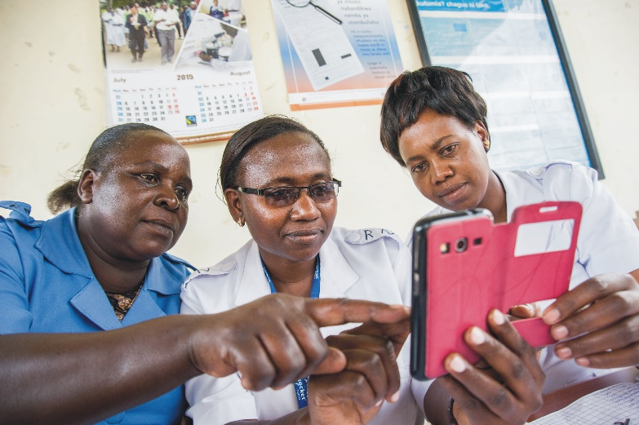leverage our deep expertise, and those of our partners.

BLN participants are part of a community that connects, learns, and collaborates across borders and health areas while accessing a series of more targeted services and mentorship. These services include:
- Advisory: The BLN serves as a one-stop-shop, addressing specific inquiries on digital and data solutions. This is done by providing countries with existing knowledge, best practices, and a possible course of action to build a responsive and efficient primary health care system.
- Capacity building: The BLN fulfills a range of technical assistance needs for countries. It strengthens country capacity on the appropriate phases of design, introduction, adoption, and the scale up and sustainability of digital and data solutions. Through close engagement and mentorship, the BLN helps countries assess their digital context; supports decision making on the technology or system that is most appropriate for their health landscape; and establishes sustainability strategies, among other topic areas.
- Knowledge management: The BLN helps to validate, develop, and disseminate lessons and tools from the broader digital health sector. Countries benefit from a strong network of country expertise in digital and data solutions, connecting, learning, and collaborating to advance their national health information systems. As active participants, members are engaged in a strong feedback loop that allows them to both benefit from and contribute to the existing knowledge base.

BLN’s guiding principles
The BLN builds a bridge between countries, and with regional and global partners, to provide targeted expertise to governments. Under this expanded scope:
- The BLN functions as an honest broker to countries and ministries of health. It provides technology agnostic and critical neutrality to country governments that must often navigate differing priorities from partners, stakeholders, and donors.
- The BLN rigorously engages countries around a spectrum of short and long-term services. It carefully assesses each country’s digital status, needs, and priorities, meeting governments wherever they are in their journey toward digital transformation.
- The BLN is country-owned and country-led. The peer learning network is not just a forum for sharing experiences, but a mechanism for gathering direct feedback from countries about pain points, what is working, and how to improve on digital and data solutions.

Country impact: Rwanda’s digital journey
Rwanda engaged the BLN to help address persistent data-related challenges to immunization service delivery. The BLN worked with the Ministry of Health (MOH) to help align its priorities for an electronic immunization registry with the country’s broader digital health agenda.
The BLN provided advisory support to the government to ensure that the country aligned internally with the larger MOH strategies to find a solution that could be customized to meet its needs, then adopted and scaled for long-term technical sustainability.
After a series of discussions on electronic immunization registries overall, the MOH decided to deploy the DHIS2 Tracker at the health facility level, while developing a custom electronic medical record system as a long-term solution.

Get in touch
The BLN offers a dynamic hub of technical support. By building local capacity, it helps to grow regional expertise and hubs of digital health leaders, providing a critical model for country-driven sustainability.
Learn more about the BLN by visiting www.bidinitiative.org.

