Facility and district visit strategy for introducing data quality and data use interventions
Introduction
The BID Initiative’s strategy to introduce new interventions addressed aspects of implementation with the products, practices, and people involved as it deployed interventions in districts and facilities. The goal of the strategy was to build the awareness, access to information, motivation and empowerment to act, and skills needed to improve data quality and use across the health system.
The initial roll-out strategy for the data quality and data use interventions under the BID Initiative was developed in September 2014. It focused on four to five visits in every facility that offered immunizations in the targeted region/province to provide on-the-job training to health workers. One or two BID staff members conducted each visit (later in Tanzania, district officials conducted the visits), which featured specific activities designed to strengthen the data use culture and provide continuity with other visits to ensure smooth implementation of the full package of interventions. The lessons learned from and the timing of the visits can be found online in the Roll-out Strategy brief.
This document focuses on the two approaches that were used: a hybrid approach in Zambia and an all on-the-job approach in Tanzania. This documents shares how these approaches worked under the BID Initiative, so that you can consider reusing or modifying based on your needs. The list below shows the different strategies used in each country to introduce the data quality and data use interventions during the four facility visits within the larger roll-out strategy. Feel free to mix and match the strategies to create an approach that best fits the needs of your country, region, or district as you introduce new interventions.
Roll-out strategies for the facility level
 | Facility visit 1 | Facility visit 2 | Facility visit 3 | Facility visit 4
Tanzania | On-the-job training | On-the-job training | On-the-job training | On-the-job training
Zambia | On-the-job training conducted by BID staff | Classroom-style training conducted by BID staff and the district staff | On-the-job training conducted by BID staff and/or district staff | On-the-job training conducted by BID staff and/or district staff

In addition to rolling out the interventions at the facilities, the BID Initiative engaged the provincial/regional and district levels in visits (also referred to as “touches” in the graphic below) that were timed to coincide with the activities happening at the facilities.
Roll-out strategies for the district level
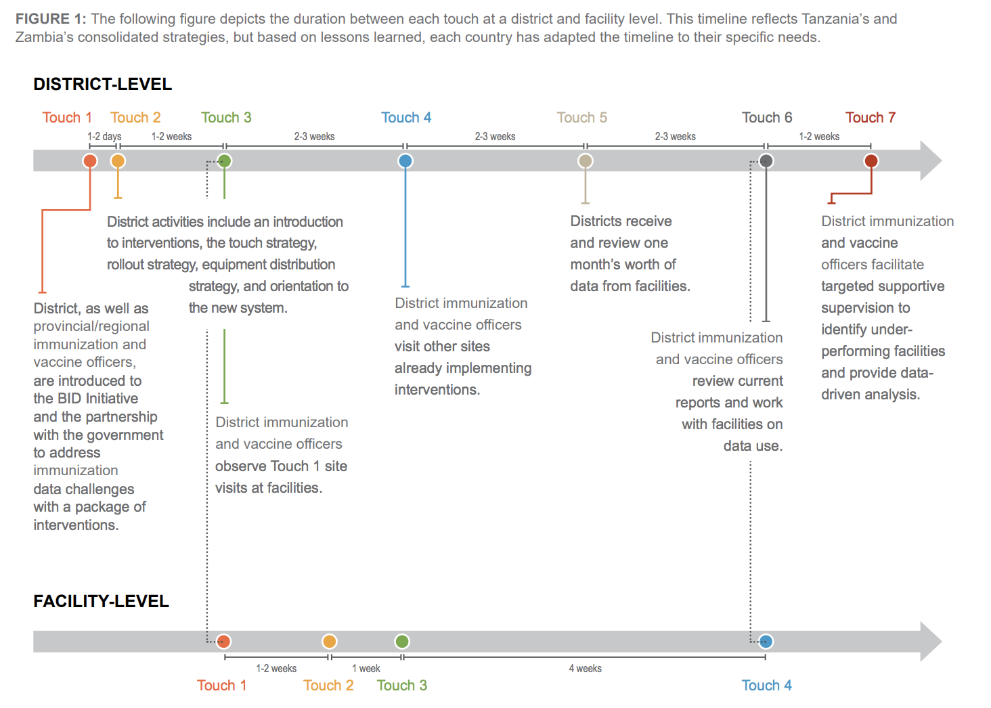
Planning-stage tools
Implementation tools are designed to plan which team members would visit specific facilities on certain days, as well as to plan visits to train health workers in the interventions. Tools include a facility fact sheet to collect useful information about the facility, such as health worker contact information, who has been trained, and what type of power sources are available at the facility (e.g., electricity from the grid and/or solar power).

District visit 1: Introduction to the data quality and data use interventions
District stakeholders—ranging from district medical office staff, council staff, community and religious leaders, and relevant nongovernmental organization staff—will meet to discuss how the data quality and data use interventions will be used and how the tools will be implemented. Invitations to this meeting should come from the district office. These key stakeholders will be able to advise on how strategies need to be refined, as well as identify potential partners with whom collaboration and synergies may be pursued. This time may also be used to reassess the various levels of communication needed to facilitate a smooth roll-out process. The agenda for this meeting should include the following:
- Introduction to the data quality and data use interventions.
- Time to walk through the new data collection tools (if relevant).
- Explanation of the roll-out strategy and what will happen during each facility visit.
- Explanation of the equipment distribution and maintenance strategy (if relevant).
- Orientation on change management and the activities.
- Explanation of the community engagement strategy.
District visit 2: Training of the district staff
This visit allows the district to have a more in-depth interaction with the data quality and data use interventions after the initial stakeholder meeting. Since the district will oversee the data quality and use of the facilities, it will be important to have time for in-depth discussion about how the interventions are designed to improve data quality and use. This visit should also focus on helping the district to identify ways to strengthen the capacity of the facilities by defining how many and what type of visits are appropriate based on available resources. The more confident the district is with the new tools and interventions, the more likely they will expect the same from their facility staff.
The structure of this visit should include the following:
- Introduction of the design of the data quality and data use interventions: Provide background on the data-related challenges that these tools are designed to resolve.
- Facility visits: Explain how the interventions will be introduced in the facilities, and highlight the district’s role in making this process a success.
- Roll-out schedule: Jointly develop a schedule for facility visits to identify considerations that should be taken into account to make the rollout more successful (e.g., programs that might pose additional time demands at the same time as the planned rollout).
- Data collection tools training: Provide a detailed step-by-step orientation on the new data collection tools (e.g., revised paper forms or devices with an electronic immunization registry).
- Change management: Provide an overview of the change management process and what interventions will be used to facilitate the change. As the district has more regular interaction with facility staff, the district can advise on how best to harness the social dynamics in the facility to improve adoption of the tools.
- Data use guide: Provide an orientation on the data use guide that will be provided.
- Lessons learned: Share any lessons learned from testing the interventions thus far and what was done to make improvements.
Facility visit 1: Introductions and change management/District visit 3: Observation
District: During this visit, the assigned district government staff will go to the facilities with the implementing team. The implementing team should consist of individuals who will be responsible for introducing the tools to health care workers. Ideally, these individuals should have some experience with behavior change and data use, and information technology skills. The district staff should take leadership in introducing the tools; this is crucial to help the facilities experience firsthand the priority that the district is giving to improving data quality and use with the interventions. Additionally, this is an opportunity for the district to experience how the facility implementation will go and where to make adjustments. This also allows the facility to see that the district owns the interventions and new data collection tools, which can open an opportunity for questions and support.
Facility: The purpose of this visit will be to introduce the new tools, changes, objectives, and goals for the selected facilities and initiate change management activities. If collecting baseline data, this is also an opportunity to gather that information.
The expected outcomes of this visit are:
- Accurate assessment of the current level of data quality and use in the facilities.
- Increased understanding of the importance of using data to make decisions.
The specific activities for this visit (and the associated tools) are:
- Change readiness assessment.
- Data use guide.
- WhatsApp group.
- Basic device training: Introduce tablet/and allow staff to practice.
- Documentation of visit:
- Ask facility staff if they have any questions, and respond accordingly.
- Note any unique questions, and share these with the rest of the implementation team.
- Document frequently asked questions, and meet with the team after the visit to develop answers.
Facility visit 2: Using the new data collection tools
The purpose of this visit, with the foundation of the data and data use assessment from the first visit, is to begin using the new data collection tools. The expected outcomes of this visit are:
- Increased skill in using the new data collection tools.
- Increased understanding of the importance of using data to make decisions.
- Increased confidence in using data to make decisions.
The specific activities for this visit (and the associated tools) are:
- Data use guide: Use this to practice using data in the tools and discuss what trends are seen and what decisions could be made.
- Issues log.
- Provide information for the help desk: Contact details.
- Assignments and documentation:
- Officially hand over tablet (or associated device) to facility staff with appropriate documentation and signatures.
- Develop in-facility orientation plan for trained staff to orient other health workers. Leave copies of the same training videos that were used to train the other health workers.
- Ask health workers to continue to practice and get very familiar with the features of the new data collection system on the device.
District visit 4: Cross-site visits and peer networking
If resources allow, the districts could have cross-site visits, particularly between districts that are in the initial stages of implementation and districts that are further along in the process. The purpose of this is to allow district staff to share experiences and lessons learned, as well as to create a network of support for each other.
Facility visit 3: Data use
The interventions and steps during this visit are to review how data are being used, work with health workers to identify trends in their data, and continue to empower health workers to use those data for decision-making.
The expected outcomes of this visit are:
- Increased understanding of the importance of using data to make decisions.
- Increased confidence in using data to make decisions.
- Improved quality, timeliness, and accuracy of reports submitted to the district.
- Improved planning and service provision in immunization.
The specific activities for this visit (and the associated tools) are:
- Review visit 2 assignments:
- Have data been entered into the tools/system?
- Have other facility staff been oriented to the new tools/system by their peers?
- Data use guide.
- Coaching supervision guide.
- Data visualization:
- Ask staff to practice creating/reviewing data visualization and telling stories from the visualizations, with possible decisions that can be made.
- Troubleshooting and mentoring:
- Ask facility staff what challenges they have experienced when using the system.
- Ask facility staff what solutions they tried to address the challenges.
- Link facility staff to super users (users who have been previously trained and available to provide support) who might help to resolve the problems.
- Conduct how-to sessions on key challenges.
- Follow up on any emerging frequently asked questions.
- Identify champions to provide ongoing support and motivation to their peers.
District visit 5: System troubleshooting and data use coaching
At this point, it is expected that the district staff should have received some reports from the facilities and should be able to view facility data at the aggregate level. The district should also be able to generate dashboards from electronic systems that use the data. In this visit, the district staff will seek to identify any challenges that the district may have experienced in using the systems and reach agreement on how to address those issues. In addition, this visit will provide coaching guides for the district to use as they provide feedback on data use to facility staff. This process will prepare the district to actively participate in the fourth facility visit.
Facility visit 4: Data use culture/District visit 6: Observation of final facility visit
District: The presence of the district at this fourth facility visit will help establish reporting requirements and expectations after the fourth visit. The key message during this visit will be that the facility staff will continue to be accountable to the district for use of the data quality and data use tools and interventions, and that the district will give support to the facilities. The district will take the lead in providing data use coaching during this visit and provide information on contact details for the help desk.
Facility: This visit is like a graduation. At the last visit, the emphasis was to work with health workers on this day to strengthen their data use and decision-making and, at the same time, ensure that the feedback loop between facilities and their district officials are established.
Expected outcomes for this visit are the following:
- Increased understanding of the importance of using data to make decisions.
- Increased confidence to use data to make decisions.
- Improved quality, timeliness, and accuracy of reports submitted to the district.
- Improved planning and service provision in immunization.
The specific activities for this visit (and the associated tools) are:
- Data use guide.
- Data use culture.
- WhatsApp:
- Review participation in peer network and WhatsApp (if applicable).
- System training and troubleshooting:
- Ask facility staff which session of the system they are having trouble with and have them demonstrate.
- Conduct how-to sessions on areas where staff are having challenges.
- Link facility staff to super users and help desk.
- Determine areas that require additional support from district, and set up schedule for support.
- Identify champions to provide ongoing support and motivation to their peers.
- Transfer the help desk responsibilities to district-level leads.
District visit 7
The implementing team should meet the district staff to conduct a joint review of the data that have come from the facilities and decide on when to conduct targeted supportive supervision to underperforming facilities.

