Stakeholder analysis
Background
Who is a stakeholder?
A stakeholder is anybody who can affect or is affected by an organization, strategy, or project. Additionally, stakeholders have the power to impact the organization’s actions, objectives, and policies.
Purpose of the stakeholder analysis
There are likely a number of stakeholders undertaking activities in maternal and child health, which includes immunizations. Prioritizing stakeholders’ involvement, from the community to the national and global levels, will play a critical role in the success and sustainability of improving data quality and use. The ability to effectively engage stakeholders starts with understanding the characteristics of each stakeholder and assessing their level of interest and influence in immunization data, whether that be stakeholders from the Expanded Program on Immunization, health management information systems, monitoring and evaluation, or information and communication technology departments.
Methodology
Individuals or teams who use this tool should work closely with the Ministry of Health at various levels to identify all stakeholders who have interest or influence in data quality and use in immunization. Under the BID Initiative, for example, a stakeholder analysis was undertaken in collaboration with the Ministry of Health, which included interviews with officials at the national, district, and facility levels. A stakeholder meeting hosted by the Ministry of Health can also generate interactions to understand various stakeholders.
Classification
The classification of stakeholders along a continuum yields four categories that correspond to broad strategies for engaging stakeholders. The four strategies are as follows:
- Low interest and low influence = monitor.
- Stakeholders in this quadrant generally need to be monitored but not necessarily actively engaged in the planning and implementation of data quality and data use interventions. The monitoring should focus on assessing whether their position on the quadrant changes and what needs to be done to respond if there is a change.
- Low interest and high influence = keep informed.
- Those in this quadrant need to be kept regularly updated on the activities and outcomes of interventions. The frequency with which this information is provided will largely depend on the preferences of the stakeholder. By keeping them informed through various relevant channels as desired, their level of influence can contribute to establishing linkages to partners who can contribute to successful implementation. At the same time, keeping them informed can reduce the probability that lack of information could result in the stakeholders developing negative perceptions that they could spread to other partners.
- High interest and low influence = keep satisfied.
- These stakeholders, while not being very influential, can be mobilized to actively contribute to the success of the project within the area where they operate. Because of their high interest, these stakeholders can provide valuable resources and feedback. The feedback aspect is particularly important considering the iterative approach to developing solutions and implementation.
- High interest and high influence = manage closely.
- The views and decisions of stakeholders in this quadrant have the potential to have immediate and lasting impact on how the project is implemented, whether their views and decisions are negative or positive. Stakeholders in this quadrant, therefore, need to be managed closely; this would involve assessing their attitude and perceptions toward the BID Initiative and taking action as required to ensure that any efforts taken are able to respond to their needs and maximize the benefit from their high level of interest and influence.
Characterizing each stakeholder as belonging to the monitor, keep informed, keep satisfied, and manage closely category should be done jointly with the Ministry of Health to understand the full picture of each stakeholder. The purpose of the classification is to provide a broad strategic direction for how to relate with each particular stakeholder.
The next phase of this stakeholder analysis would be to validate the ratings and to agree on strategies for how to specifically engage each stakeholder, as relevant.

Stakeholder classification exercise
List the names of global-level stakeholders here, as well as the acronyms of their names, if applicable. Use the acronyms to map the stakeholder influence in the chart below.
- GK – Good Kids foundation
- IG – International Grant organization
- IU – Informatics University
- C³ – Caring Communities for Children

Below is an example classification of the global-level stakeholders for the made-up Healthy Kids Initiative.
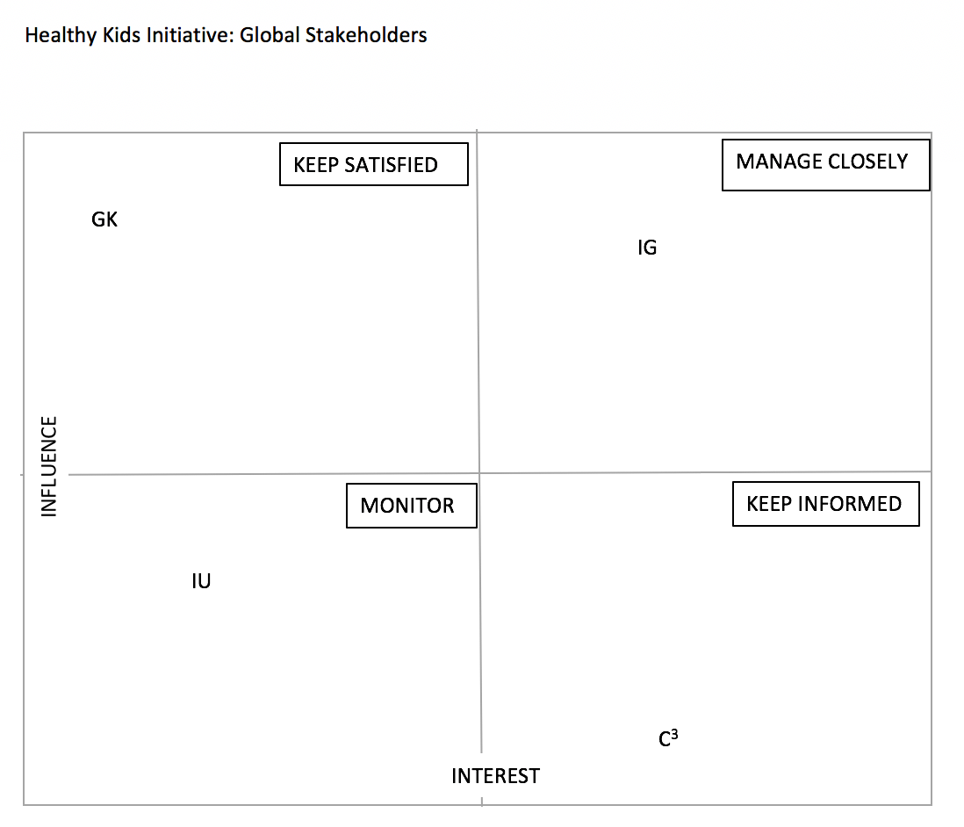
LOW
HIGH
HIGH

Stakeholders at the global level
Step 1: List the names of global-level stakeholders here, as well as the acronyms of their names. Use the acronyms to map the stakeholder influence in the chart below.

Step 2: Use the quadrant below to map your global stakeholders.

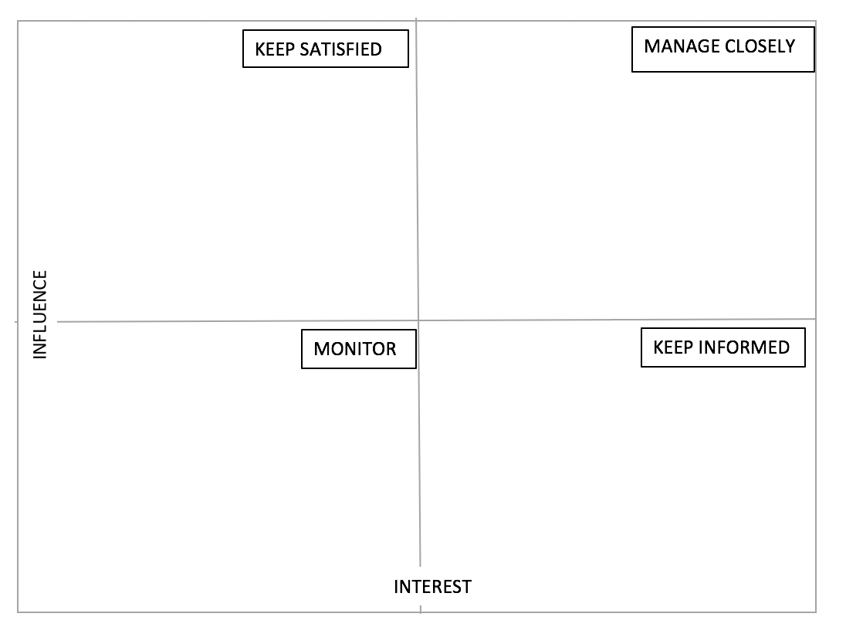
HIGH
LOW
HIGH
Stakeholders at the national level
Step 2: List the names of national-level stakeholders here, as well as the acronyms of their names. Use the acronyms to map the stakeholder influence in the chart below.

Step 1: Use the quadrant below to map your national-level stakeholders.

HIGH
LOW
HIGH
Stakeholders at the regional/provincial level
Step 1: List the names of provincial-/regional-level stakeholders here, as well as the acronyms of their names. Use the acronyms to map the stakeholder influence in the chart below.

Step 2: Use the quadrant below to map your regional-/provincial-level stakeholders.

HIGH
LOW
HIGH
Stakeholders at the district level
Step 1: List the names of district-level stakeholders here, as well as the acronyms of their names. Use the acronyms to map the stakeholder influence in the chart below.

Step 2: Use the quadrant below to map your district-level stakeholders.

HIGH
LOW
HIGH
Stakeholders at the facility and community level
Step 1: List the name of stakeholders at the facility and community levels here, as well as the acronyms of their names. Use the acronyms to map the stakeholder influence in the chart below.

Step 2: Use the quadrant below to map your facility- and community-level stakeholders.

HIGH
LOW
HIGH
Stakeholder engagement plan
Using the mappings above, list each stakeholder in detail in the table below. Objectives should explain why this stakeholder should be engaged (e.g., this stakeholder oversees policies on immunizations in the country). Areas of interest should depict the shared interest between you and that stakeholder.

Stakeholder | Objective (why engage) | Areas of interest | Information needed | Platforms used and frequency | Team members responsible
National/global example
Gavi, the Vaccine Alliance | - Work with new vaccinations development.  - Work with underused vaccines.  - Increase accessibility for poor/remotely located children. | - Immunization coverage and equity. | - Updates on progress of data quality and data use interventions.  - Documentation of challenges and successes. | - Meetings.  - Email updates.  - Online platforms.  - Engagement of senior country manager. | Director or Senior Manager
World Health Organization | - Global health and infectious diseases.  - Support and align priorities and donor interests. | - Child health immunization.  - Maternal health. | - Updates on progress.  - Linkages between systems and partners. | - Events.  - Online platforms. | Director or Senior Manager
National/global | Objective (why engage) | Areas of interest | What info/interaction do they need? | What platforms will be used? | Team members responsible
Regional/Provincial (name region/province) | Objective (why engage) | Areas of interest | What info/interaction do they need? | What platforms will be used? | Team members responsible
District | Objective (why engage) | Areas of interest | What info/interaction do they need? | What platforms will be used? | Team members responsible
Facility/Community | Objective (why engage) | Areas of interest | What info/interaction do they need? | What platforms will be used? | Team members responsible

