Nigeria
Routine Immunization Overview

Routine Immunization Coverage Trends
Indicators
(WHO/UNICEF, 2011, See notes 1 and 2)
Total population | 162,471,000
Infant mortality rate | 88
Surviving Infants | 5,877,000
Infant DTP1 | 53%
Infant DTP3 | 47%
Infant measles | 71%
Unimmunized (by DTP3) | 3,114,810

According to official country reports, infant immunization coverage in Nigeria, as reported by DTP3, increased significantly from 57% in 2008 to 74% in 2010. This was followed by a significant drop to 61% in 2011. These reported coverage improvements were primarily due to the country’s decision in 2006 to add multiple antigens and other child survival interventions to the polio eradication campaigns (now referred to as Immunization Plus Days or IPDs) that are held every 4-6 weeks in the northern polio endemic states and at least twice per year nationally. Given the challenges with disaggregating IPD and routine immunization data sub-nationally, denominator issues, and also increased routine immunization focus nationwide through the Reaching Every Ward (REW) approach, official country estimates have greatly fluctuated since 2007. The DHS conducted in 2008 pointed to coverage rates that were significantly lower than official country reports. In 2011, Nigeria’s immunization program failed to reach 47% (or 2,762,190) of its target population of children under one year of age with even a first dose of the DTP vaccine. There was a 6% drop-out rate between DTP1 and DTP3 in 2011. The population’s use of routine immunization services is determined by their access to, demand for, and acceptance of those services.
Infant DTP3 Coverage, 1980-2011 (Official Country, WHO/UNICEF and Survey Estimates)
Source | 1985 | 1990 | 1995 | 2000 | 2005 | 2006 | 2007 | 2008 | 2009 | 2010 | 2011
Official Country (3) | 9% | 56% | 34% | 38% | 38% | 72% | 69% | 57% | 71% | 74% | 61%
WHO/UNICEF (1) | 16% | 56% | 34% | 29% | 36% | 40% | 42% | 53% | 63% | 69% | 47%
2003 DHS: 20%

2008 DHS: 33%

(4) 1990 DHS: 29%
(5) 2006 NICS: 36%

(6) 2007 MICS: 28%

2009 NIS: 68%

2011 DTP Left-out (accessibility) and Drop-out rateds (availability/use) (7) (WHO/UNICEF estimates 2011)
Left-out rate = 47% of surviving infants (DTP1)

Drop-out rate = 6% of infants who received DTP1 did not complete the DTP series
47% left-outs
6% drop-out rate

2009 DTP3 Coverage by State (based on administrative reports/service statistics)
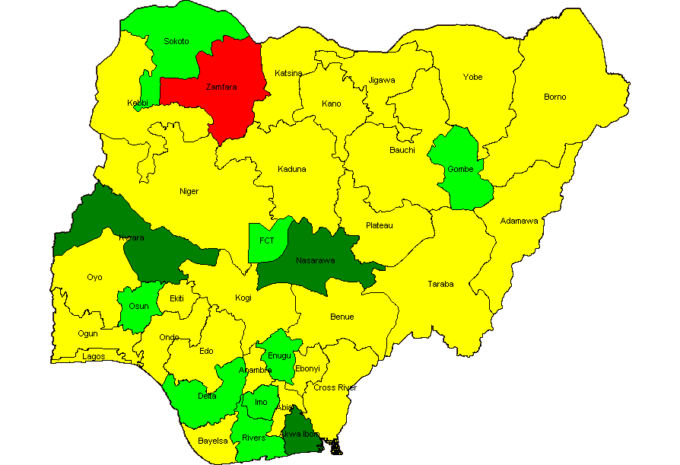
National coverage estimates often mask sub-national differences in performance. In the visual mapping of Nigeria’s DTP3 coverage for 2009, clear variations in coverage are evident across the country's 36 states and federal capital territory. Similar maps can be used showing the numbers of unimmunized children, drop-out rates, vaccine stock outs and other program indicators by state or LGA are helpful in identifying specific performance problems requiring attention. This type of mapping exercise should be done at least annually, using administratively reported data. Immunization managers should also use administrative reports to make day-to-day program decisions. Even when those reports overestimate coverage (especially >100%), as is the case in Nigeria, they can be used effectively to track and compare immunization performance by administrative unit. Routinely calculating and comparing performance indicators makes it possible for program managers to take action before problems become acute.
DTP3 <50% DTP3 50-79% DTP3 ≥80% DTP3 > 100%

Nigeria and the GAVI Alliance (as of July 2011)
Current comprehensive Multi-year Plan (cMYP): 2011–2015; Current Health Sector Plan dates: 1998–2010
Through mid 2011, Nigeria had been approved for over $225 million in GAVI Alliances support GAVI Alliance. Nigeria applied for pentavalent (DPT, Hepatitis B, Haemophilus influenzae type b [Hib]) and pneumococcal vaccine in June 2009. It has committed to co-finance $48,508,500 for pentavalent between 2012 and 2015 and $30,576,000 for pneumococcal between 2013 and 2015. Because of GAVI’s revised eligibility criteria for new and underutilized vaccines (requiring ≥70% DTP3 coverage based on WHO/UNICEF estimates), Nigeria cannot yet apply for new vaccine support against rotavirus.
Type | Dates | Support $
Injection Safety Support (INS)
 | 2008-2010 | 12,630,270 | (in progress)
Immunization Services Support (ISS) (8)
 | 2001-2001, 2006-2007 | 47,324,000 | (in progress)
Health System Strengthening Support (HSS) (9)
 | 2008-2013 | 44,704,000 | (in progress)
New Vaccine Support (NVS) (10)
Penta (11) | 2012-2015 | 124,736,000 | (in progress)
Yellow Fever | 2004, 2007-2015 | 49,776,313 | (in progress)
Pneumo | 2013 | 46,643,500 | (in progress)
Men-A Campaign | 2011-2013 | 61,275,500 | (in progress)

In addition to support for new and underused vaccines, Nigeria also received Injection Safety Support (INS) commodities since 2008 and Immunization Services Support (ISS) investment funding since 2001. It received its last ISS reward funding in 2007 and has reapplied for ISS funding in June 2009. So far, Nigeria reports using the majority of its ISS funding for training and outreach. In 2008, Nigeria received GAVI’s newest type of support, Health System Strengthening (HSS), which has been targeted to cold chain, training and rehabilitation of Primary Health Care facilities.

USAID’s global Maternal and Child Integrated Program (MCHIP) would like to encourage USAID/Nigeria (and its partners) to support the inter-agency coordination committee (ICC), the health sector coordination committee (HSCC), and the Core Group efforts to strengthen routine immunization. USAID’s global investment in routine immunization through the GAVI Alliance and others will only be protected with your continuous involvement and support.

Notes and Resources

(1) WHO/UNICEF coverage estimates consider population-based survey results as well as Official Country Estimates. They are generated and published annually and used to track coverage trends.
http://www.who.int/immunization_monitoring/en/globalsummary/timeseries/tswucoveragebycountry.cfm?country=NGA

Infant mortality rate: the probability of dying between birth and exactly one year of age. The infant mortality rate is expressed as the number of infant deaths per 1,000 live births.
Surviving infants: the number of children who have survived beyond their first year of life. Source: WHO/UNICEF.
Unimmunized infants (DTP3): Calculated as the number of surviving infants X (1.00 – DTP3 coverage). Calculations made using surviving infants and DTP3 coverage from WHO/UNICEF estimates. http://www.who.int/immunization_monitoring/en/globalsummary/countryprofileresult.cfm

(2) The third dose of diphtheria, pertussis, tetanus (DTP3) is commonly used as a surrogate indicator for routine immunization coverage. DTP vaccine is predominantly offered in fixed health facilities and routine (commonly) monthly outreach sessions. Polio and measles vaccines are frequently given during campaigns, as well as in fixed health facilities and during routine outreach sessions. Completion of the DTP series by one year of age requires vaccination services to be offered on multiple occasions and for those services to be accessible, available, acceptable to and sought by the target population.

(3) Official Country Estimates of immunization coverage come from the annual Joint Reporting Form (JRF) that each
country submits to WHO and UNICEF. These estimates are most often based on administrative reports from health facilities. http://www.who.int/immunization_monitoring/en/globalsummary/timeseries/tscoveragebycountry.cfm?C=NGA

(4) Demographic and Health Surveys (DHS). http://www.measuredhs.com/countries/country_main.cfm?ctry_id=30&c=Nigeria
All collected data on children 12-23 months of age by card and history. The DHS estimates in this table are for DTP3 coverage by 12 months of age, as documented by card and applied to coverage by recall. All DHS and standard immunization coverage surveys describe the coverage situation at least one year before they were conducted, thus the positioning of the blue markers (marker placement is either in the middle of the year prior to year of survey, or on the border of the survey year when a gap in years exists in the table).

(5) The 2003 and 2006 National Immunization Coverage Survey (NICS) estimates in this table are collected using the same situation as the DHS—coverage by 12 months of age as documented by card and applied to coverage by card and recall, thus similarly describing the coverage situation at least one year before the surveys were conducted.

(6) The Multiple Indicator Cluster Survey 2007 estimates represent preliminary results, http://www.childinfo.org/. The data used in the table are estimates for DTP3 coverage by 12 months of age, as documented by card, and applied to coverage by recall, thus like the DHS and NICS, the data describe the coverage situation at least one year before the survey was conducted.

(7) Drop-outs are people who begin the vaccination schedule but do not complete it. Left-outs are people who were never reached for vaccination. http://www.immunizationbasics.jsi.com/Docs/Imm_Essentials_2009.pdf (pp.47-50)

(8) Immunization Services Support (ISS) payments are disbursed according to Annual Progress Reports and are contingent on countries increasing the number of children immunized each year. These payments are called reward payments because the country is being paid a reward of $20 for each child immunized. Countries are allowed to apply for ISS for the duration of the comprehensive Multi-Year Plan (cMYP).

(9) Health System Strengthening (HSS) payments are allocated based on the birth cohort and the GDP per capita of the country. Countries are allowed to apply for HSS for the duration of their Health Sector Plan (or equivalent).

(10) New vaccines are delivered to countries based on the target population and the co-financing paid by each country. All countries are being approved until 2015, but the actual number of vaccine doses disbursed is revised each year when the country submits its Annual Progress Report.

(11) Pentavalent vaccine protects against diphtheria, pertussis, tetanus, hepatitis B, and Haemophilus influenzae type b.

MCHIP: 1776 Massachusetts Avenue NW, Suite 300, Washington, DC 20036 tel: 202.835.3100 e-mail: info@mchip.net
Koki Agarwal, Director, kagarwal@mchip.net; Anita Gibson, Deputy Director, agibson@mchip.net
USAID: 1300 Pennsylvania Avenue, Washington, DC 20523 tel: 202.712.4564
Nahed Matta, AOTR, nmatta@usaid.gov; Lily Kak, Alternate AOTR, lkak@usaid.gov

www.mchip.net

